**ShopBridge Installation Documentation**

**Database Configuration**

1. Execute the below Query in SSMS to create “ShopBridge” database

IF NOT EXISTS (SELECT * FROM master.sys.databases

WHERE name='ShopBridge')

BEGIN

CREATE DATABASE ShopBridge

END

1. Execute the below Query in SSMS to create “MeasurementUnit” table

USE [ShopBridge]

GO

/****** Object: Table [dbo].[MeasurementUnit]

Script Date: 25-05-2021 18:38:48 ******/

SET ANSI_NULLS ON

GO

SET QUOTED_IDENTIFIER ON

GO

IF NOT EXISTS (SELECT * FROM sysobjects WHERE name='MeasurementUnit' and xtype='U')

BEGIN

CREATE TABLE [dbo].[MeasurementUnit](

[Id] [int] NOT NULL,

[Description] [nvarchar](200) NOT NULL,

PRIMARY KEY CLUSTERED

(

[Id] ASC

)WITH (PAD_INDEX = OFF, STATISTICS_NORECOMPUTE = OFF, IGNORE_DUP_KEY = OFF, ALLOW_ROW_LOCKS = ON, ALLOW_PAGE_LOCKS = ON) ON [PRIMARY]

) ON [PRIMARY]

END

GO

INSERT INTO MeasurementUnit(Id,Description)

Values

(1,'Piece'),

(2,'Kilogram'),

(3,'Litre')

1. Execute the below Query in SSMS to create “ProductStatus” table

USE [ShopBridge]

GO

/****** Object: Table [dbo].[ProductStatus] Script Date: 25-05-2021 18:40:35 ******/

SET ANSI_NULLS ON

GO

SET QUOTED_IDENTIFIER ON

GO

IF NOT EXISTS (SELECT * FROM sysobjects WHERE name='ProductStatus' and xtype='U')

BEGIN

CREATE TABLE [dbo].[ProductStatus](

[Id] [int] NOT NULL,

[Description] [nvarchar](200) NOT NULL,

PRIMARY KEY CLUSTERED

(

[Id] ASC

)WITH (PAD_INDEX = OFF, STATISTICS_NORECOMPUTE = OFF, IGNORE_DUP_KEY = OFF, ALLOW_ROW_LOCKS = ON, ALLOW_PAGE_LOCKS = ON) ON [PRIMARY]

) ON [PRIMARY]

END

GO

INSERT INTO ProductStatus(Id,Description)

Values

(1,'Instock'),

(2,'Sold'),

(3,'OutOfStock'),

(4,'Received')

1. Execute the below Query in SSMS to create “Product” table

USE [ShopBridge]

GO

/****** Object: Table [dbo].[Product] Script Date: 25-05-2021 18:39:13 ******/

SET ANSI_NULLS ON

GO

SET QUOTED_IDENTIFIER ON

GO

IF NOT EXISTS (SELECT * FROM sysobjects WHERE name='Product' and xtype='U')

BEGIN

CREATE TABLE [dbo].[Product](

[Id] [int] IDENTITY(1,1) NOT NULL,

[Name] [nvarchar](100) NOT NULL,

[Description] [nvarchar](100) NULL,

[Quantity] [int] NOT NULL,

[BaseUnit] [int] NOT NULL,

[MRPRate] [decimal](18, 0) NOT NULL,

[SellingPrice] [decimal](18, 0) NOT NULL,

[LastModifiedTime] [datetime] NOT NULL,

[CreatedTime] [datetime] NOT NULL,

[ProductStatus] [int] NOT NULL,

PRIMARY KEY CLUSTERED

(

[Id] ASC

)WITH (PAD_INDEX = OFF, STATISTICS_NORECOMPUTE = OFF, IGNORE_DUP_KEY = OFF, ALLOW_ROW_LOCKS = ON, ALLOW_PAGE_LOCKS = ON) ON [PRIMARY]

) ON [PRIMARY]

END

GO

ALTER TABLE [dbo].[Product] WITH CHECK ADD CONSTRAINT [FK_BaseUnit] FOREIGN KEY([BaseUnit])

REFERENCES [dbo].[MeasurementUnit] ([Id])

GO

ALTER TABLE [dbo].[Product] CHECK CONSTRAINT [FK_BaseUnit]

GO

ALTER TABLE [dbo].[Product] WITH CHECK ADD CONSTRAINT [FK_ProductStatus] FOREIGN KEY([ProductStatus])

REFERENCES [dbo].[ProductStatus] ([Id])

GO

ALTER TABLE [dbo].[Product] CHECK CONSTRAINT [FK_ProductStatus]

GO

1. You could also find this query’s inside the “DBFiles” folder in Project folder inside the “ShopBridge.Base” project.

**Download Project from GitHub**

1. Download the Project from the below given github link

https://github.com/CSKarthick/ShopBridge

1. After clicking the above link github site will open like shown below

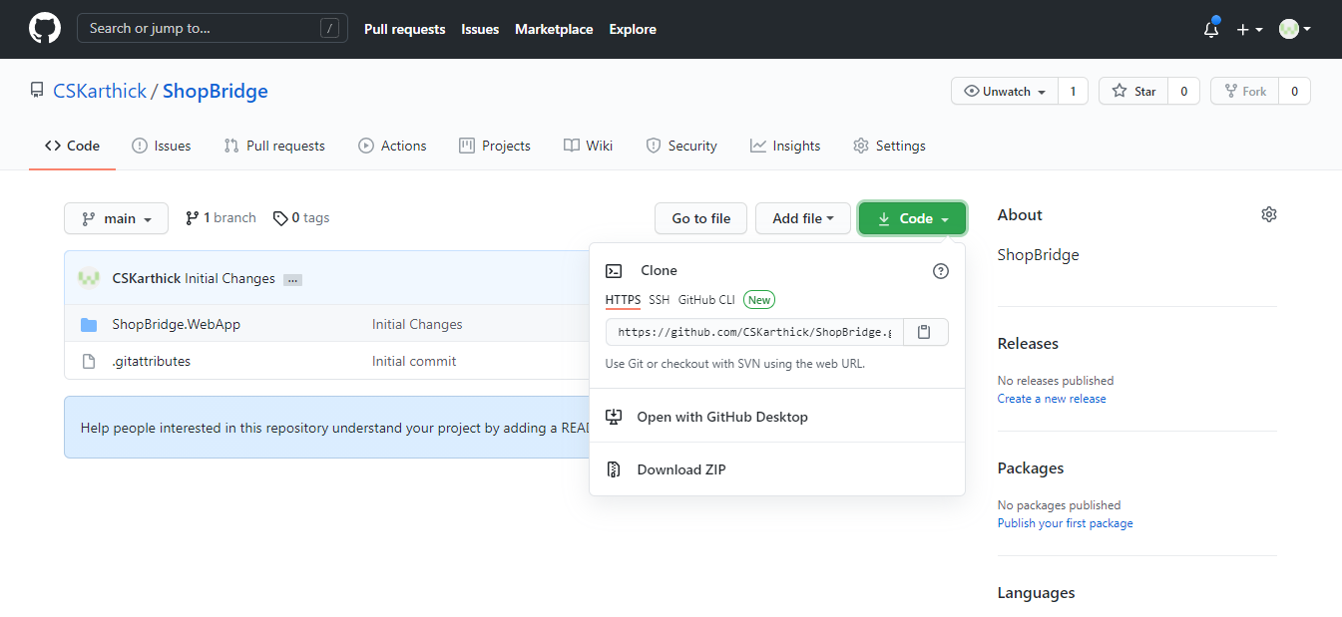

1. Click on “**DownloadZip**” it will downloaded in the downloads folder.
2. Extract the zip file.
3. After Extract the Zip file, inside the **ShopBridge-main** folder. Open the “ShopBridge" folder and open “appsettings.json” in notepad.
4. Change the “**Data Source**” value with your machine “sql server name” in the “**SqlServerConnectionString**” as Shown below

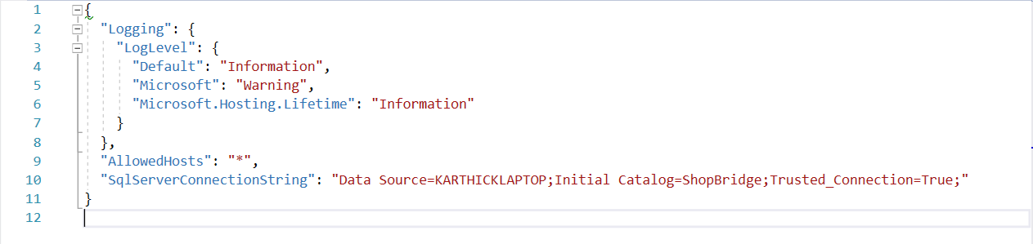

1. Save the “appsetting.json” file and open the **ShopBridge.sln** inside ShopBridge folder.
2. Open the Solution file in Visual Studio.
3. Set ShopBridge.WebApp as a “**start up project**” as shown below.

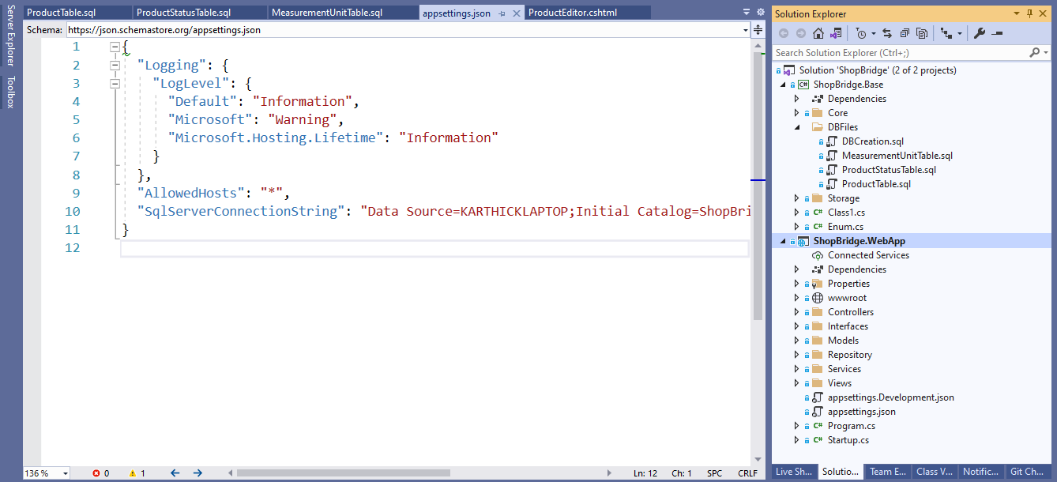

1. Execute the project.